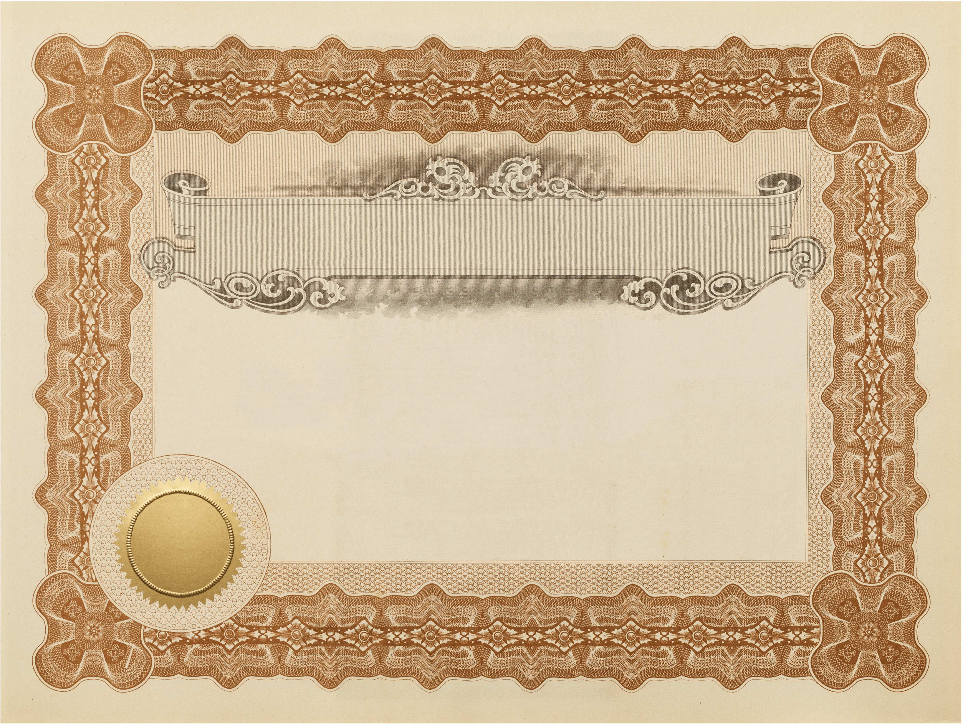

h

Marriage Certificate
This is to Certify that

_ _ And Were Wed on the _ Day of _ _ In the year _ _ At: _.
_ _ _ Bride Groom
Certificate Donated by 2014

